**Project Task: 1 (This is on the Business Analysis concepts)**

**Identifying Stakeholders – Create a list of Stakeholders**

**1). Oliver (CEO):**

* Oliver should be able to login in to this system.
* Using this tool, He can view menu.
* Using this system, he can get the reports regarding which is the most popular dish, sales of the day, total earnings, List of dishes not sold in the current month, etc.
* Using this system, he should be able to see feedback from customers as manually entered by managers.

**2). Managers:**

* Managers can access or should be able to login in to this system.
* Using this system, Manager should be able to create new menus from scratch, add new items, delete existing items from menu.
* Managers should be able to view menu or search items in the menu using the search facility.
* Using this system, Manager should be able to reserve tables.
* Using this system, manager should be able to manually enter details of feedback form given to customers.
* Using this tool, management can get the reports regarding which is the most popular dish, sales of the day, total earnings, List of dishes not sold in the current month, etc.

**3). Waiters:**

* Waiter should be able to login in to this system and will have limited access to all features.
* Using this system, waiter should be able to generate bills table-wise.
* Waiters should be able to view menu or search items in the menu using the search facility.
* Using this system, waiter shall be able to see which tables are reserved so that he does seat anyone on reserved table.

**Create As-Is and Future Process map (using flowcharts)**

**As- Is Process map:**

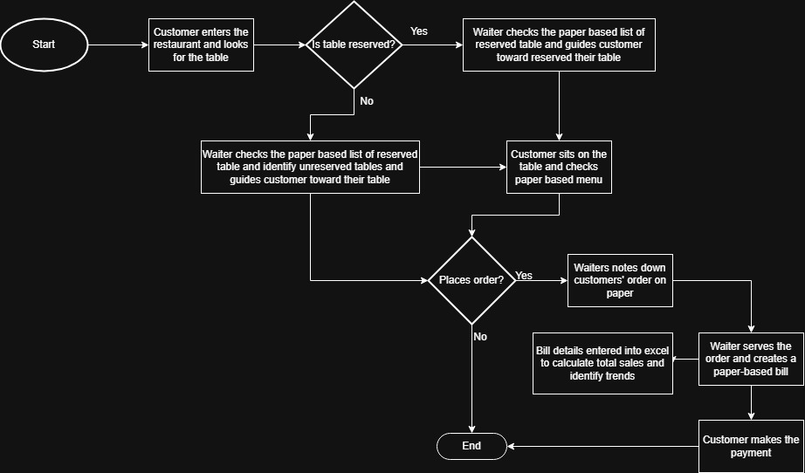

**Future Process map:**

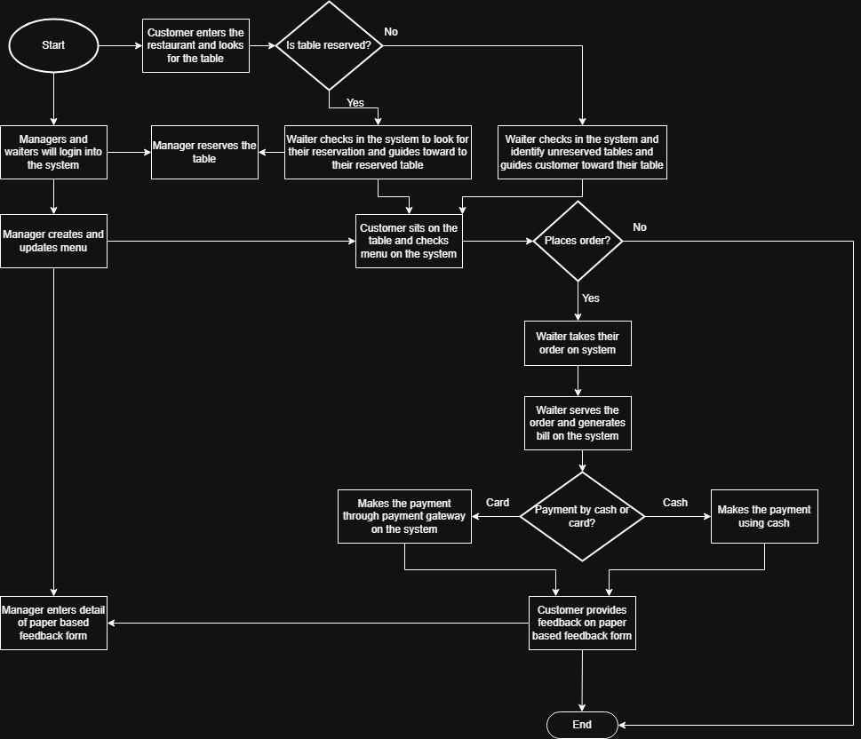

**As a Business Analyst working on this project, find out the scope of the Restaurant Management Software.**

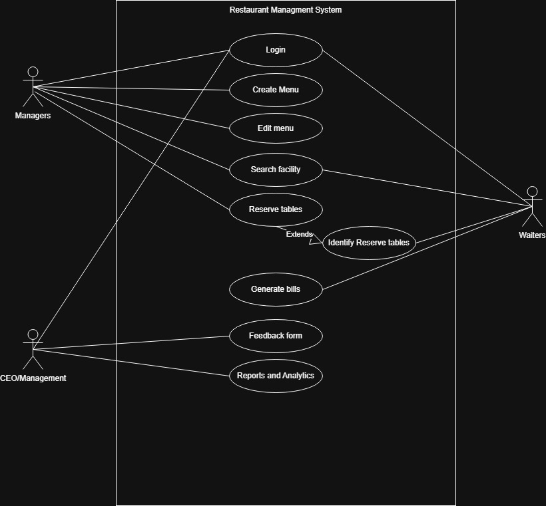

**Write down the main features that need to be developed**

The restaurant management system will have following features:

* Login: The system should have a login facility for waiters, managers and CEO Oliver. Also, system should have an option to change password.
* Menu creation: This system will have a feature to create menu. Every item in the menu stored should be categorized into certain categories and each item should be saved in the system along with its price.
* Editing and updating a menu: This system will give managers an option to edit the menu created. They should be able to add new items, delete existing items.
* Search facility: This system will allow waiters and managers to search items in the menu using the searchfacility.
* Reserving table: The table layout is to be stored in the system which allows managers to reserve tables and allows waiters to look into the software to determine which tables are reserved.
* Generating bill: This system will allow waiter to generate bill table wise, in a manner that, every bill will be tagged to the waiter generating it and the table number.
* Payment gateway: This system will have payment gateway using which customers can pay by card.
* Feedback form: It will allow managers to enter details of paper feedback form given to customers into the system.
* Report and analytics: Using this tool, management can get the reports regarding which is the most popular dish, sales of the day, total earnings, List of dishes not sold in the current month, etc.

**Write the in-scope and out-of-scope items for this software  
In-Scope:**

* Login: This feature will allow CEO Oliver, waiters and managers to login and have access to the software.
* Menu creation: This system will allow managers to create menu in categorized manner.
* Editing and updating menu: It will enable managers to add new items and delete existing items from menu.
* Search facility: This system will allow managers and waiters to search items in the menu.
* Reserve table: This system will enable managers to reserve tables and allow waiters to look into system to identify which table is reserved.
* Generating bill: It will enable waiters to generate bill through it in order to replace paper-based bills.
* Payment gateway: It will have payment gateway using which customers can pay by cash or card.
* Feedback form: It will enable managers to enter details of paper feedback form given to customers into the system.
* Report and analytics: Using this tool, management can get the reports regarding which is the most popular dish, sales of the day, total earnings, List of dishes not sold in the current month, etc

**Out of scope:**

* Customers feedback is collected on a paper feedback form which is later on inputted by the managers on the system. So, this system does not have any feature to collect feedbacks directly from customers and replace this paper-based feedback form.
* Customers cannot access this system. They cannot search for items in menu, place their order on their own and give feedback directly on the system.
* In this system, waiters have limited access. They will not be given the option to create and edit menu, reserve tables and enter details from feedback forms as these functionalities are only available for managers and not for waiters.

**Write out the business requirements, both functional and nonfunctional requirements**

**Functional requirements:**

* Login
* Change Password
* Create Menu
* Addition and deletion of items in menu
* Search facility
* Store table layout
* Reserve table
* Generate bill
* Payment gateway
* Input Feedback form details
* Report and analytics

**Non-Functional requirements:**

* Usability: The screens should be self-explanatory and very user friendly. Management would not want waiters facing issues while using it as they cannot understand the screens and data fields on screen.
* Environments: This program is going to be created and maintained through Java. It has been chosen because it will not change much over time and there will be very little maintenance to be done on the code.
* Performance: The software should be light and render fast especially during peak time and performs its designated functions with minimum consumption of resources.
* Safe and secure: This software should be safe and secure as it contains sensitive personal information of customers as collected through payment gateway and feedback forms, etc.

**Draw wireframes or mock screens for two of the features namely *menu creation* and *table reservation*.**

**Menu Creation**

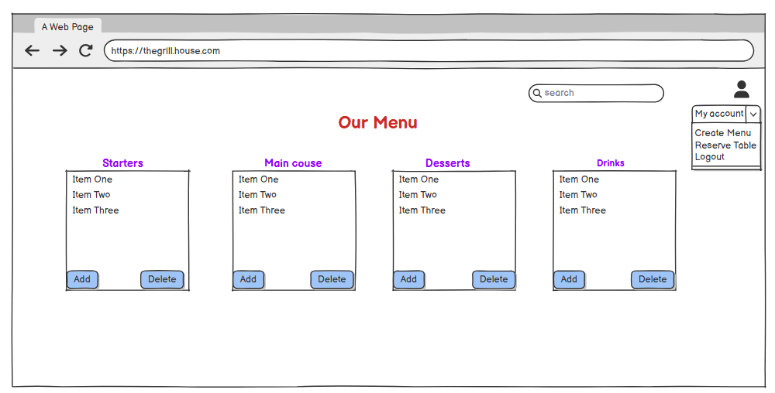

**Table Reservation**

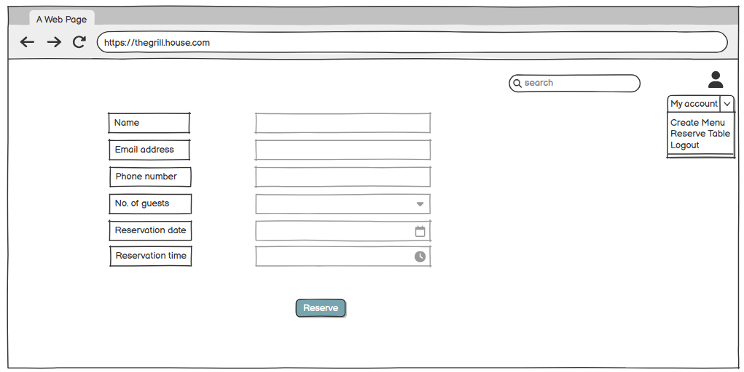

**Project Task: 2 (This is on the agile scrum concepts )**

**Make a product backlog of user stories for the given case study.**

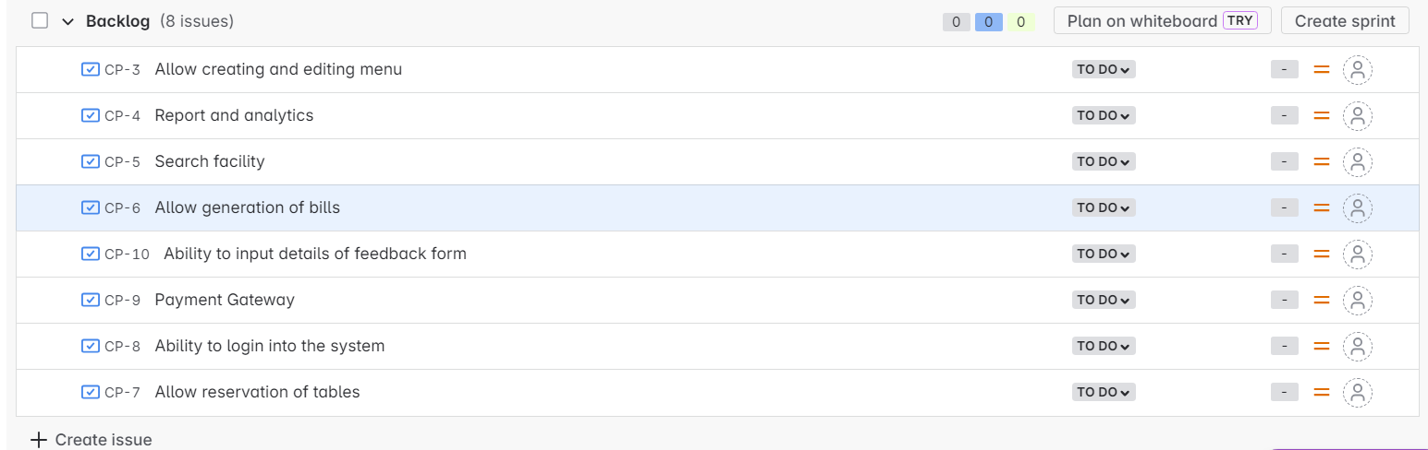

**For each story, write the acceptance criteria**

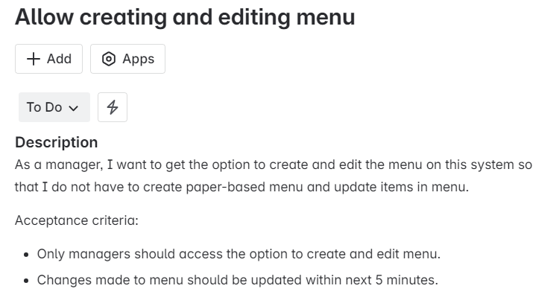

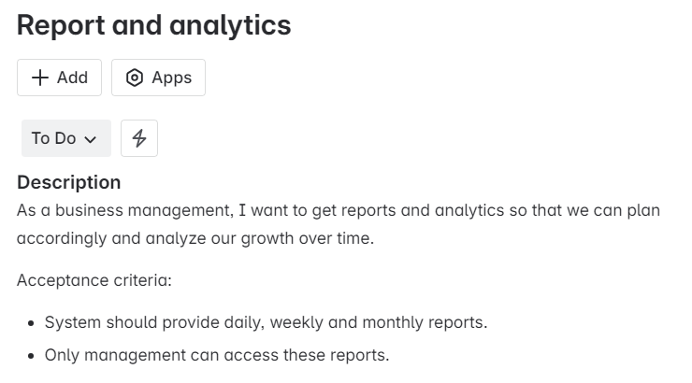

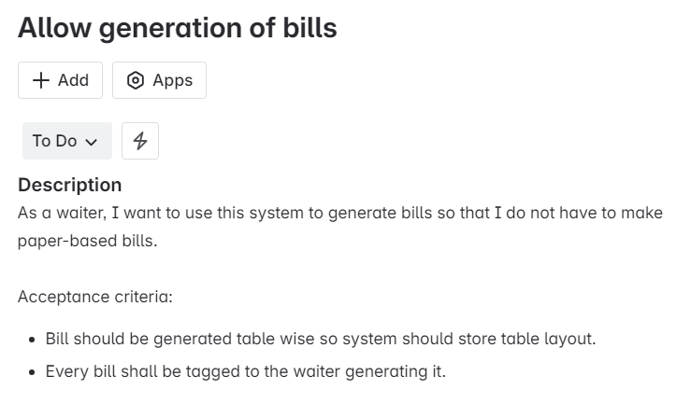

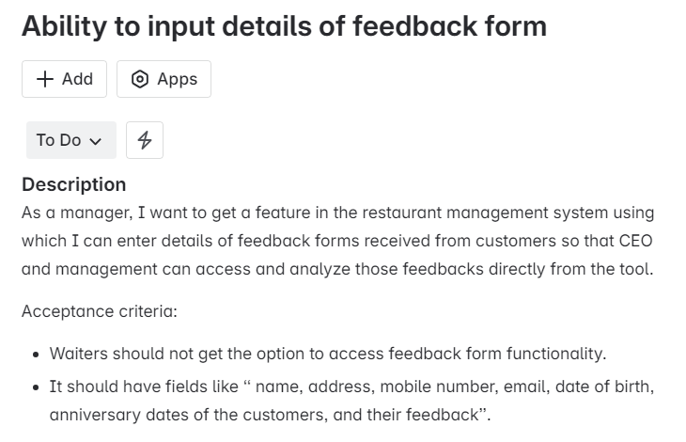

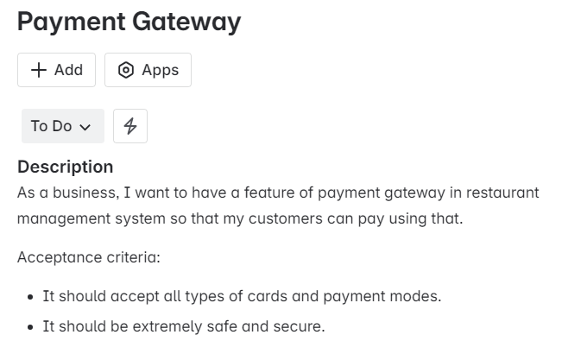

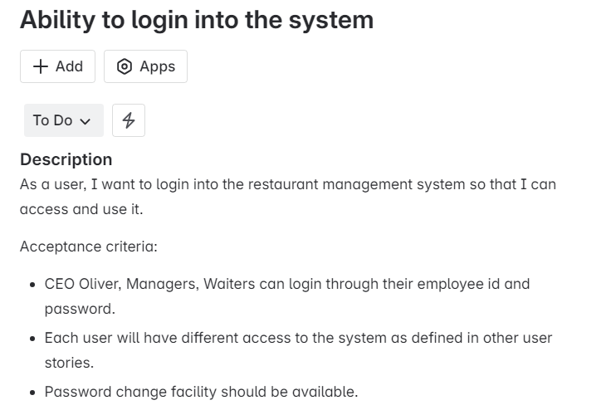

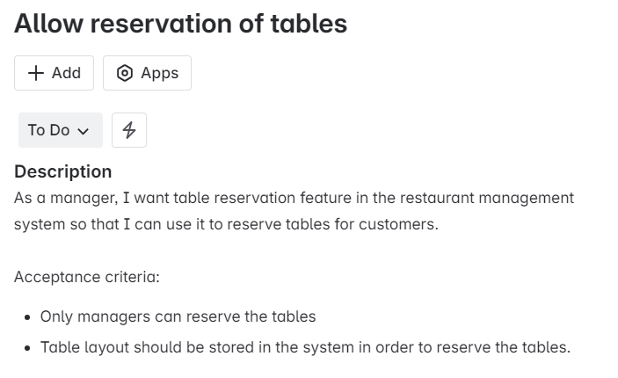

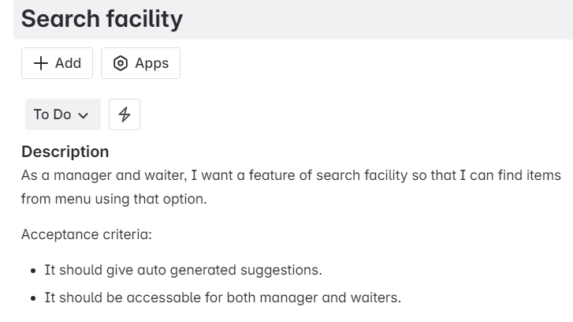

**Project Task: 3 (This is on the Tableau concepts)**Create a dashboard for senior management to view sales of restaurants for the last six months and to show which zone (Zone 1, 2, 3, or 4) has highest sales.

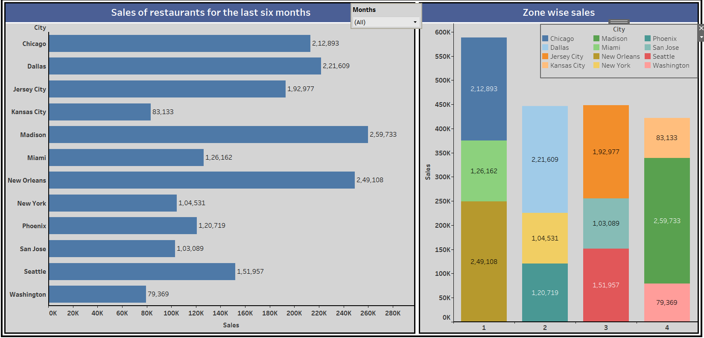

**Project Task: 4 Excel concepts**

Create a bar graph for San Jose, Madison, and New York showing the sales. Label the chart drawn correctly so that senior management gets a clear report of sales.